User Story 2
As a developer, I want the AI to generate multiple related code files at once so that I do not need to manually stitch files together.

Development Specification 2:
Chat Log Links: P2-resubmission-chat-histories
https://chatgpt.com/share/69082a0b-077c-8008-9246-df833237659d

1. Header
Version: v2.0 (2025-11-2)
Authors:
- Christina Ma
- Baolin Shi
- Dejun Yang

2. Architecture Diagram
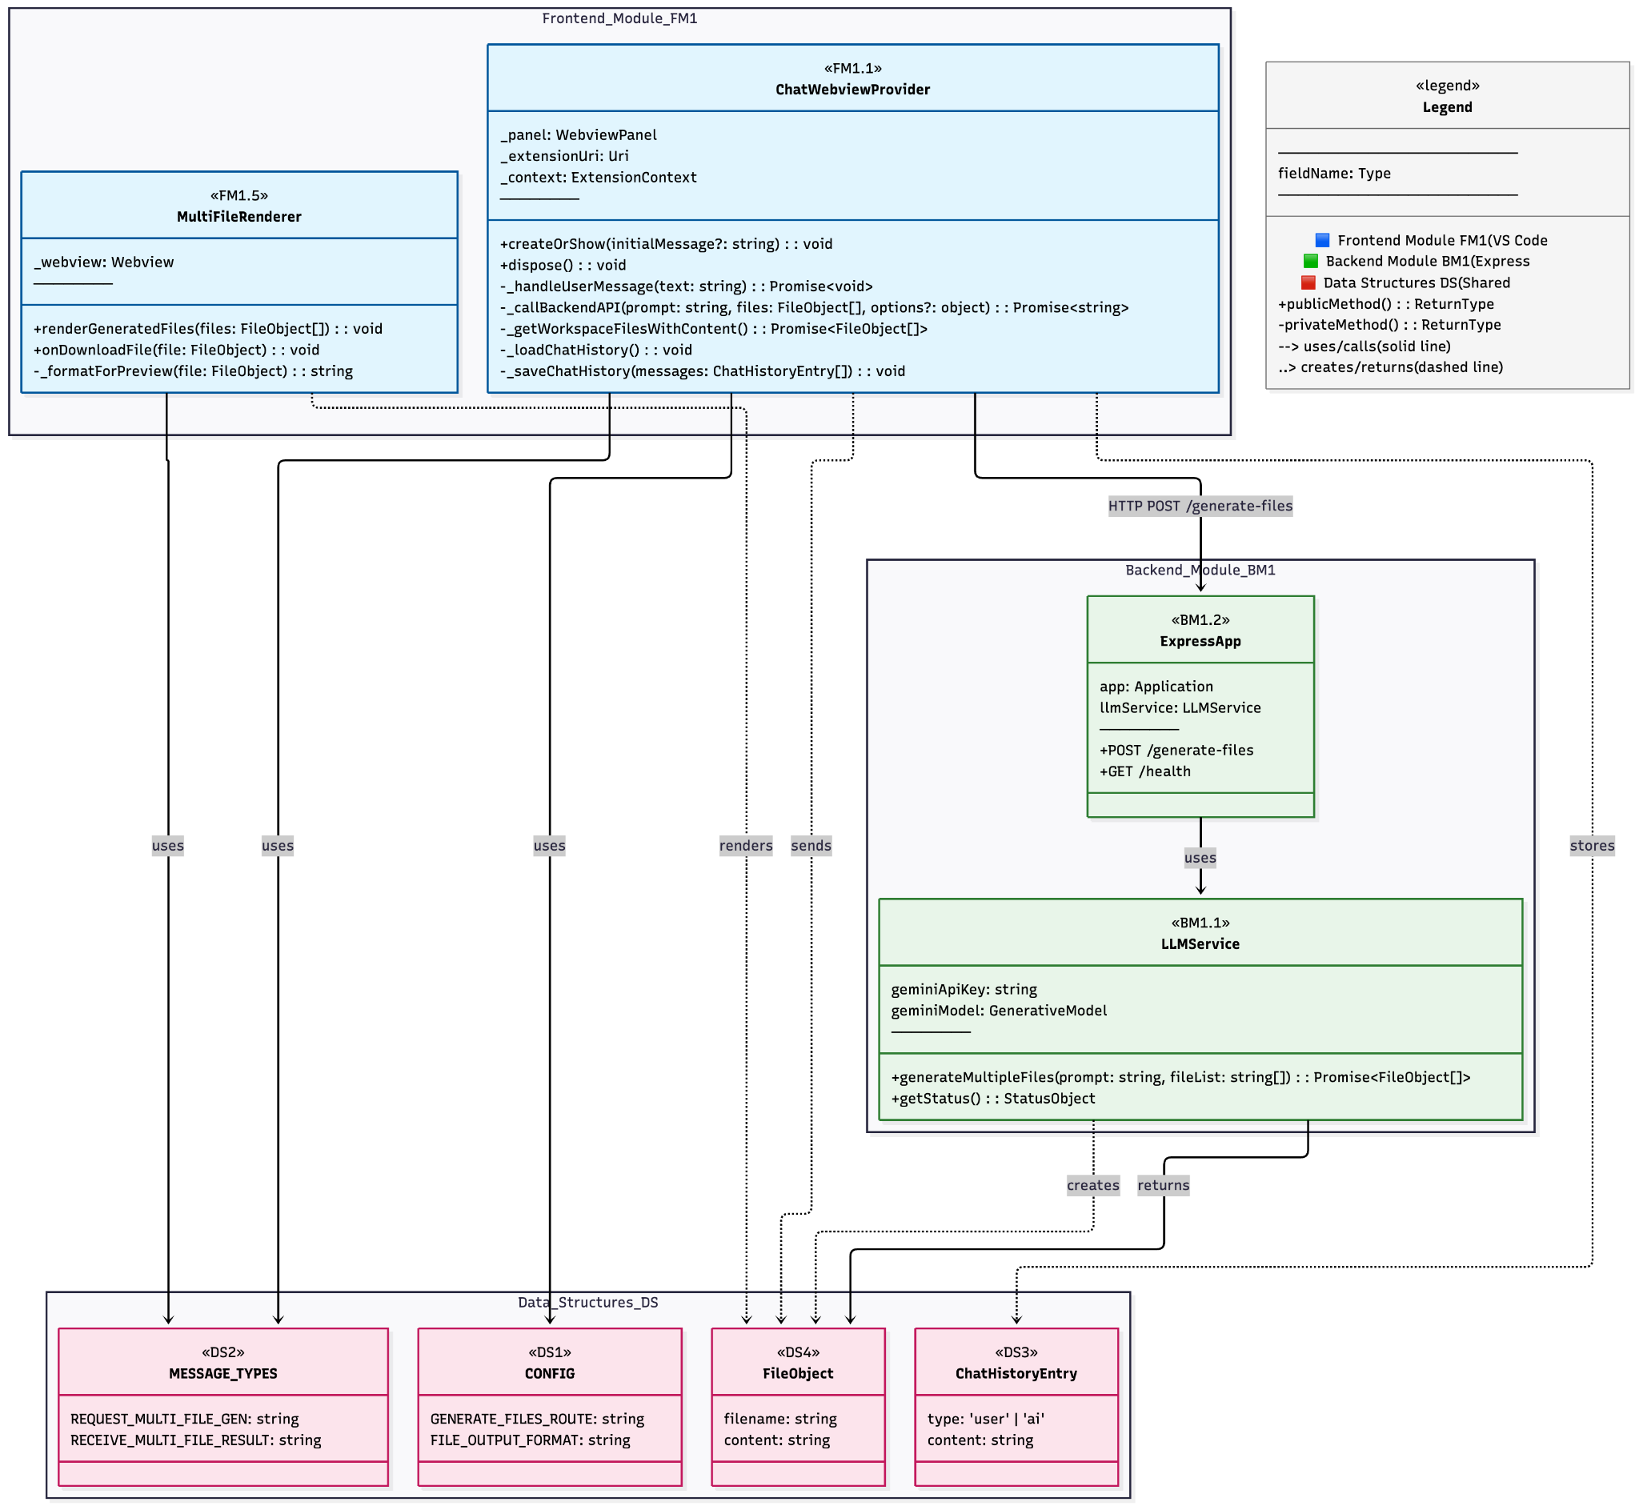
Rationale:
This architecture builds on the existing frontend–backend design from User Stories 1 and 3, adding support for AI-generated multi-file output. It introduces a MultiFileRenderer in the frontend to render and download multiple generated files, and extends the backend’s LLMService with a generateMultipleFiles() method. Communication is handled via a new /generate-files endpoint, reusing existing data structures like FileObject and ChatHistoryEntry to maintain consistency. The design ensures seamless integration with repo-awareness (US1) and citation features (US3), while keeping modules loosely coupled for future extensibility.

3. Class Diagram
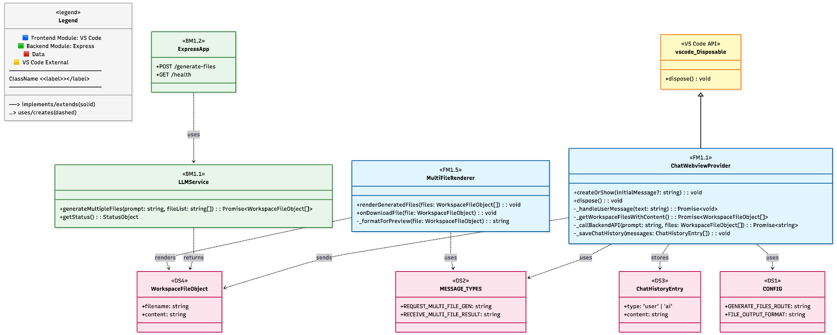
Rationale:
This class diagram extends the shared application architecture by introducing MultiFileRenderer on the frontend and enhancing LLMService on the backend to support multi-file generation. It maintains consistency with User Stories 1 and 3 by reusing core classes such as ChatWebviewProvider, WorkspaceFileObject, and MESSAGE_TYPES, while ensuring that the new components integrate cleanly through clearly defined responsibilities. The diagram follows proper inheritance from the VS Code API and uses composition to model interactions between frontend, backend, and shared data structures.

4. List of Classes
Frontend Module (FM1)
FM1.1 ChatWebviewProvider
- Location: frontend/ai-chatbot-extension/src/chatWebviewProvider.ts
- Purpose: Core controller for the webview panel. Collects workspace files, sends prompts to backend, and receives multi-file responses. Updated for US2 to route multi-file outputs to the new MultiFileRenderer.
- Implements: US1 (repo awareness), US2 (multi-file generation), US3 (citation buttons)
- Type: VS Code Extension Class (TypeScript)
FM1.2 ChatViewProvider
- Location: frontend/ai-chatbot-extension/src/chatViewProvider.ts
- Purpose: Tree data provider for the VS Code sidebar chat interface. No changes for US2, but reused across all user stories.
- Implements: US1/2/3 – navigation to chatbot interface
- Type: VS Code Tree Data Provider Class (TypeScript)
FM1.3 ChatViewItem
- Location: frontend/ai-chatbot-extension/src/chatViewProvider.ts (lines ~60–75)
- Purpose: Individual item in the AI Chatbot sidebar tree view. Links to ChatWebviewProvider.
- Implements: US1/2/3 – entry point to chatbot
- Type: VS Code Tree Item Class (TypeScript)
FM1.5 MultiFileRenderer
- Location: frontend/ai-chatbot-extension/src/multiFileRenderer.ts
- Purpose: Renders multiple AI-generated files returned from the backend. Displays filenames, file previews, and includes download functionality. New for US2.
- Implements: US2 – display and interaction with multiple file results
- Type: Webview UI Renderer (JavaScript/TypeScript module)

Backend Module (BM1)
BM1.1 LLMService
- Location: backend/services/llmService.js
- Purpose: Core logic for AI interaction using Gemini. Adds a new method generateMultipleFiles(prompt, files) which returns an array of {filename, content} objects. Reused and extended from US1.
- Implements: US1/2/3 – AI generation engine
- Type: Service Class (JavaScript)

BM1.2 ExpressApp
- Location: backend/index.js
- Purpose: Express server exposing endpoints. Adds new endpoint POST /generate-files for US2, in addition to /upload and /summarize-with-citations. Routes requests to LLMService.
- Implements: US1/2/3 – server and routing logic
- Type: Express Application Instance (JavaScript)

Data Structures
DS1 CONFIG
- Location: frontend/ai-chatbot-extension/src/chatWebviewProvider.ts (lines ~10–20)
- Purpose: Webview configuration constants (view type, column number, panel titles). Reused across all stories.
- Type: Configuration Object (TypeScript const)
DS2 MESSAGE_TYPES
- Location: frontend/ai-chatbot-extension/src/chatWebviewProvider.ts (lines ~25–37)
- Purpose: Message type constants for frontend–backend communication. US2 adds REQUEST_MULTI_FILE_GEN, RECEIVE_MULTI_FILE_RESULT.
- Type: Message Type Constants (TypeScript const)
DS3 ChatHistoryEntry
- Location: frontend/ai-chatbot-extension/src/chatWebviewProvider.ts (around _loadChatHistory/_saveChatHistory)
- Purpose: Stores each chat message ({type: 'user' | 'ai', content: string}), used for persisting and restoring conversation state.
- Type: Interface (TypeScript)
DS4 WorkspaceFileObject
- Location: chatWebviewProvider.ts (~line 240) and index.js (request payload)
- Purpose: { filename: string, content: string }. Used throughout system to represent file content sent to the backend.
- Type: Shared File Object (TypeScript/JavaScript)
DS5 WorkspaceDirectoryTree
- Location: backend/services/llmService.js (method generateDirectoryTree)
- Purpose: Tree structure representing folders and files in the workspace. Helps AI understand repo structure.
- Type: Recursive Tree Object (JavaScript)
Rationale:
We organized the class list by module (Frontend, Backend, Data Structures) and kept the file locations for traceability during development. New components (e.g., MultiFileRenderer, generateMultipleFiles) are cleanly isolated and labeled. Shared classes from US1 are reused for consistency. This structure enables fast navigation, verification, and alignment across all three dev specs.

5. State Diagram
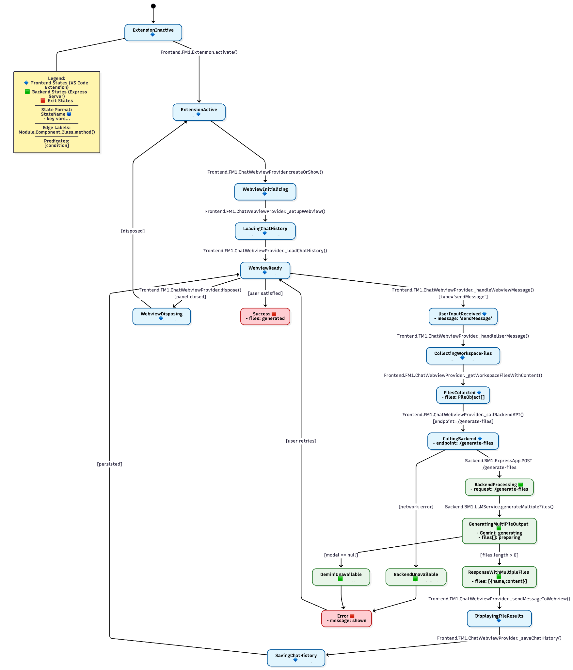
Rationale:
The state diagram for User Story 2 models the frontend and backend transitions involved when a user requests the generation of multiple related code files (e.g., React + CSS + test). We reused foundational states from User Story 1 (e.g., extension activation, file collection, backend communication) and added new states to capture the multi-file generation flow: AI file planning, file content generation, response streaming, and file preview rendering. Each state clearly identifies tracked variables, and transitions are annotated with method calls scoped by Module.Component.Class.method() for consistency. We included error states for common failures like file structure mismatch or Gemini API issues. This diagram ensures traceability across user intent, backend processing, and frontend file handling, helping us validate and debug the entire code generation experience.

6. Flow Chart
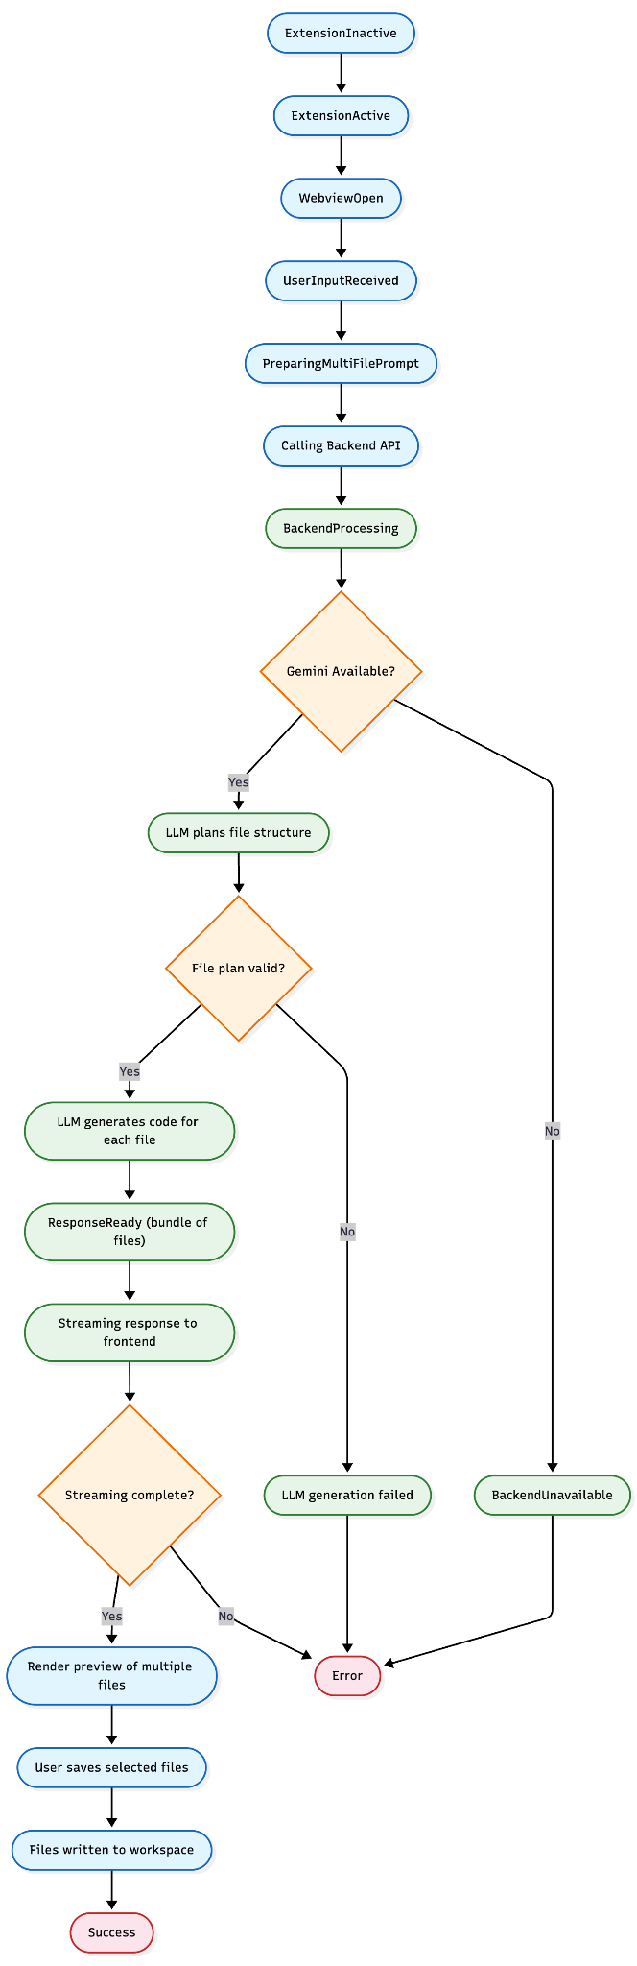
Rationale:
This flowchart outlines the end-to-end process for AI-driven multi-file code generation, beginning with the user prompt and ending with file preview and saving. It separates frontend and backend responsibilities and includes key decision points like Gemini availability, file plan validity, and streaming completion. By visualizing steps such as file planning, code generation, streaming, and user confirmation, the flowchart ensures clarity around error handling and system robustness. This concise structure supports both implementation and future debugging of complex multi-file generation workflows.

7. Development Risks and Failures

System Components Overview
- Frontend: VSCode Extension (TypeScript)
- Backend: Node.js Express Server (JavaScript)
- AI Service: Google Gemini API Integration
- Communication: HTTP/HTTPS API calls
- Storage: Local VSCode extension storage
- New Components (US2): FilePlanView (frontend), FilePlanner & MultiFileStreamer (backend)

Runtime Failures
F30: Invalid File Plan Format
- Likelihood: Medium | Impact: Medium
- User-visible effects: “Save Files” button disabled or error shown in plan preview
- Internal effects: Frontend rejects malformed or unsafe file plan structure
- Recovery procedure:
  - Validate plan schema before display
  - Show error with guidance in preview
  - Prevent submission until corrected
F31: Write Failure to Workspace
- Likelihood: Medium | Impact: High
- User-visible effects: Some or all generated files not saved, partial output written
- Internal effects: vscode.workspace.fs.writeFile() fails due to path conflicts or permission issues
- Recovery procedure:
  - Retry writes with delay
  - Fall back to prompt user to select a valid folder
  - Log error and show notification in webview
F32: Streaming Interrupt Mid-Generation
- Likelihood: Medium | Impact: Medium
- User-visible effects: Code stops mid-file; some files are missing
- Internal effects: Gemini stream terminated unexpectedly; backend buffer incomplete
- Recovery procedure:
  - Show warning with partial file list
  - Offer “Retry Generation” button with saved plan
  - Backend retry with exponential backoff
F33: Inconsistent File Content Across Files
- Likelihood: Low | Impact: High
- User-visible effects: Files refer to missing imports, mismatched class names
- Internal effects: AI response lacks internal consistency when generating related files
- Recovery procedure:
  - Add static checker after file generation
  - Alert user to review files before saving
  - Auto-generate a summary report of class/function declarations
F34: File Preview Rendering Error
- Likelihood: Low | Impact: Medium
- User-visible effects: Plan shows empty or misformatted preview
- Internal effects: Webview renderer fails to decode streamed Markdown/code
- Recovery procedure:
  - Fall back to raw text rendering
  - Log rendering error in dev console
  - Fix decoding bug in next update
F35: Overwrite Conflict with Existing Files
- Likelihood: Medium | Impact: Medium
- User-visible effects: Existing files unexpectedly overwritten or merged
- Internal effects: File save logic fails to detect existing path
- Recovery procedure:
  - Add overwrite confirmation dialog
  - Automatically rename or version conflicting files
  - Show diff preview before apply
Rationale:
The failures and risks above focus on the new interactive features introduced by User Story 2, including file plan validation, multi-file streaming, file preview, and workspace writing. While general failures from User Story 1 (e.g., backend crash, API loss, extension state issues) still apply, we only document newly introduced risks here to avoid redundancy. Mitigations rely on a combination of static validation, stream monitoring, user feedback, and graceful fallbacks.

8. Technology Stack
Total Technologies: 16
Backend Technologies: 8 (T1–T8)
Frontend Technologies: 8 (T9–T16)
Production Dependencies: 8 (T1–T5, T9–T11)
Development Dependencies: 8 (T6, T12–T15, T7–T8, T16)
Architecture: VS Code Extension with a separate backend API server
Languages: TypeScript (frontend) + JavaScript (backend)
Runtime: Node.js v16+
AI Integration: Google Gemini via official SDK
Backend Technologies
T1: Node.js (v16.x or higher)
- Purpose: JavaScript runtime environment for backend server
- Why chosen: Industry standard for JS servers, rich async and streaming support
- Docs | NPM
- Version: ≥16.0.0
T2: Express.js (v4.18.2)
- Purpose: Web framework for handling HTTP routes
- Why chosen: Flexible and lightweight for API design
- Docs | NPM
- Version: ^4.18.2
T3: Google Generative AI SDK (@google/generative-ai v0.24.1)
- Purpose: Access Gemini models for streaming multi-file responses
- Why chosen: Official, type-safe Gemini API support
- Docs | NPM
- Version: ^0.24.1
T4: CORS (v2.8.5)
- Purpose: Enable frontend-backend communication
- Why chosen: Required middleware for browser API calls
- Docs | NPM
- Version: ^2.8.5
T5: dotenv (v16.3.1)
- Purpose: Load .env config into backend runtime
- Why chosen: Secure way to manage API keys and ports
- Docs | NPM
- Version: ^16.3.1
T6: Nodemon (v3.0.1) (Dev Dependency)
- Purpose: Hot-reload backend during development
- Why chosen: Boosts iteration speed
- Docs | NPM
- Version: ^3.0.1
T7: Built-in Node.js Modules
- Purpose: Use fs, path, stream, assert etc. for file streaming
- Why chosen: Lightweight, already included in runtime
- Docs
- Version: Included in Node.js v16+
T8: Bash Shell Scripting
- Purpose: Shell scripts for deployment (e.g., deploy.sh)
- Why chosen: Common CLI-based deployment scripting
- Docs
- Version: OS dependent

Frontend Technologies (VS Code Extension)
T9: VS Code Extension API (@types/vscode v1.82.0)
- Purpose: Develop and register VS Code commands, panels
- Why chosen: Required API for extension development
- Docs | NPM
- Version: ^1.82.0
T10: TypeScript (v4.9.4)
- Purpose: Type-safe development for the extension
- Why chosen: Improves reliability and maintainability
- Docs | NPM
- Version: ^4.9.4
T11: Axios (v1.6.0)
- Purpose: HTTP client for frontend-backend streaming communication
- Why chosen: Easy async/streaming API calls
- Docs | NPM
- Version: ^1.6.0
T12: ESLint (v8.28.0) (Dev Dependency)
- Purpose: Code quality enforcement
- Why chosen: Standard linting tool in TS projects
- Docs | NPM
- Version: ^8.28.0
T13: @typescript-eslint/parser (v5.45.0) (Dev Dependency)
- Purpose: ESLint parser for TS
- Why chosen: Required for TS syntax compatibility
- Docs | NPM
- Version: ^5.45.0
T14: @typescript-eslint/eslint-plugin (v5.45.0) (Dev Dependency)
- Purpose: TypeScript-specific lint rules
- Why chosen: Enforces TS best practices
- Docs | NPM
- Version: ^5.45.0
T15: @types/node (v16.x) (Dev Dependency)
- Purpose: Node.js type declarations
- Why chosen: Adds type safety for built-in modules
- Docs | NPM
- Version: 16.x
T16: Built-in Node.js Modules (Frontend)
- Purpose: File path resolution, streaming via fs and path
- Why chosen: Required for writing files in workspace
- Docs
- Version: Included with Node.js v16+
Rationale:
User Story 2 required robust handling of multi-part file streaming, plan preview, and safe file system interaction, which is why Node’s built-in modules and Gemini’s streaming API were critical. The rest of the tech stack remains consistent with US1/US3 and is validated against package.json and package-lock.json.

9. APIs
US2 introduces logic for generating and rendering multiple related files from a single LLM response. This builds on top of the core LLMService and ExpressApp from US1, but introduces new parsing and preview handling logic.

BM1.1 – LLMService (AI Response Generation Service)
New Public Method
BM1.1.10 generateMultiFileResponse(prompt, files)
- Parameters:
prompt: string – User input prompt
files: FileObject[] – Repository file context
- Returns: Promise<MultiFileResult> – Object containing multiple file plans and associated metadata
- Purpose: Triggers Gemini generation and parses multiple file outputs
- Used by: BM1.2.1 POST /upload endpoint
New Private Helpers
- BM1.1.p3 _parseMultiFileOutput(responseText): FilePlan[]
  - Parses LLM response into structured FilePlan[], each with filename, path, content, overwrite flag
- BM1.1.p4 _validateFilePlan(plan: FilePlan): boolean
  - Ensures paths, extensions, and sizes are valid
- BM1.1.p5 _generatePreviewMarkdown(filePlan: FilePlan): string
  - Produces HTML/Markdown preview of proposed changes

BM1.2 – ExpressApp (HTTP Server)
BM1.2.1 POST /upload (Extended for US2)
- Request Body:

{
"files": FileObject[],
"prompt": string
}
- 
Response (extended):

{
"message": string,
"aiResponse": string,
"directoryTree": object,
"filePlans": FilePlan[],
"previewMarkdown": string[],
"llmStatus": object,
"metadata": {
"filesProcessed": number,
"generatedFiles": number,
"timestamp": string
}
}
- 
Purpose: Accepts prompt and file context, returns parsed multiple file suggestions with previews
- Used by: FM1.1.11 _handleUserMessage

FM1.1 – ChatWebviewProvider (Webview Manager)
New Private Methods (Frontend Integration)
- FM1.1.27 _renderMultiFilePreview(filePlans)
  - Creates a sidebar or modal showing each proposed file and preview diff
- FM1.1.28 _confirmMultiFileWrite(filePlans)
  - Prompts user for confirmation before writing any file
- FM1.1.29 _writeFilesToWorkspace(filePlans)
  - Calls VS Code FS APIs to write each file, handles collision if file exists

Rationale: US2 extends existing APIs in a modular way by introducing a new generateMultiFileResponse() method and extending /upload with richer response fields like filePlans[] and previewMarkdown[]. New frontend methods support preview, confirmation, and safe writing of multiple files into the workspace. This approach ensures backward compatibility with US1 and enhances UX for multi-file generation.

10. Public Interfaces

Within Backend Module (BM1)
- BM1.2 uses BM1.1:
  - POST /upload → LLMService.generateResponse() (same as US1)
  - POST /upload → LLMService.generateDirectoryTree() (same as US1)
  - POST /upload → LLMService.prepareFileContext() (NEW: explicitly used to inject file context into prompt)

Within Frontend Module (FM1)
- FM1.1 uses FM1.1 (internal):
  - _handleUserMessage() → _getWorkspaceFilesWithContent() (same)
  - _handleUserMessage() → _getCurrentFile() (NEW: US2-specific context awareness)
  - _handleUserMessage() → _callBackendAPI(prompt, files) (same)

Cross-Module (Frontend → Backend)
- FM1.1 uses BM1.2:
  - _callBackendAPI() → HTTP POST /upload
    - Sends: { prompt, files, currentFile }
    - Receives: { aiResponse, directoryTree, llmStatus, metadata }

External Dependencies
- FM1 (Frontend) uses VS Code API:
  - vscode.window.activeTextEditor – Gets the current open file (NEW for US2)
  - vscode.workspace – File system access
  - vscode.ExtensionContext – Persisting extension state
- BM1 (Backend) uses:
  - @google/generative-ai – Gemini model query (same)
  - express, cors, dotenv – HTTP routing and config (same)
Rationale:
User Story 2 extends the existing interfaces by adding awareness of the currently open file in both frontend and backend. No new endpoints were created; instead, additional fields are added to existing API calls (e.g., currentFile) to enrich prompt context. This design preserves interface consistency while improving context relevance.

11. Data Schemas
We do not maintain a database storage for our extension.

12. Security & Privacy

PII Temporarily Stored
- API Keys and Tokens
  - Data: Gemini API keys, VSCode extension tokens
  - Justification: Required for authenticating AI service and extension functionality
  - Source: User configuration, .env variables
  - Flow: User input → Extension settings → Backend service → Gemini API
  - Usage: API authentication and request processing
  - Disposal: Held in memory only, cleared post-use
  - Protection: Stored in environment variables, transmitted over HTTPS
- Code Content + Current File Context
  - Data: Source code file contents, file paths, currently open file
  - Justification: Required to provide rich, contextual prompts to LLM (especially current editing file)
  - Source: VS Code workspace via extension APIs
  - Flow: VSCode workspace → Extension → Backend → Gemini API
  - Usage: Prompt enhancement and semantic understanding
  - Disposal: Not persisted; discarded after request completes
  - Protection: Transmitted via HTTPS, held in volatile memory only
- Chat Messages
  - Data: User queries, AI-generated responses
  - Justification: Required for conversation continuity
  - Source: User input from chat interface
  - Flow: Extension → Backend → Gemini → Extension storage
  - Usage: Chat interface display, session state
  - Disposal: Stored only in local VSCode extension state
  - Protection: Stored in globalState, encrypted if supported

PII Long-term Storage
- Chat History
  - Data: Query/response messages
  - Justification: Enables conversation history recall
  - Storage: VSCode extension global state (context.globalState)
  - Responsibility: Extension developer & VSCode platform
  - Audit: Via extension usage logs
- Extension Settings
  - Data: API keys, preferences, configuration
  - Justification: Necessary for customization
  - Storage: Stored in VSCode Settings UI
  - Audit: Accessed via settings logs

Security Responsibilities
- Data Storage Security
  - Extension: VSCode globalState (sandboxed)
  - Backend: No persistent data, memory-only processing
  - Keys: User-managed, .env-protected
- Privacy Policy
  - Location: README + Marketplace listing
  - Content:
    - No long-term data collection
    - Gemini is the only third-party processor
    - User has full control over retention
    - No transmission to unauthorized third parties
- Access Control Policies
  - Temporary Access: All data cleared after request
  - Long-term Access: Only chat stored, user-visible
  - Administrative Access: Limited to dev team
  - Third-party Access: Gemini API for inference only

Audit & Compliance
- Audit Procedures:
  - Standard logs: request timestamps, anonymized data
  - Error logs and debugging sessions (dev-only access)
- Minors Protection:
  - No explicit solicitation
  - Same data practices for all users
  - No abuse-prone features (e.g., no external chat or uploads)

Security Measures
- Data Protection:
  - HTTPS for all traffic
  - File data held only in memory
  - No backend persistence layer
- Infrastructure:
  - Node.js backend, Gemini access via SDK
  - Secure headers, content sanitization
  - API key access only
- Incident Response:
  - Log-based detection
  - Rapid rollback via shell deployment
  - User notified via extension update / GitHub issue
Rationale:
User Story 2 slightly increases sensitivity by including the user’s current open file, but all data continues to be processed temporarily and securely. The system emphasizes minimal retention, transparent access, and alignment with VS Code’s privacy model.

13. Risks to Completion
Here is Section 13: Risks to Completion for User Story 2, focusing on the challenges introduced by current file awareness and file filtering, while retaining the relevant risks from US1:

13. Risks to Completion (US2)

Technology Stack Analysis
(Same as US1 – no new frameworks introduced)
- T1: Node.js (v16+) – Low difficulty, easy maintenance
- T2: Express.js (v4.18.2) – Low learning curve, highly stable
- T3: Google Generative AI SDK (@google/generative-ai v0.24.1) – Medium complexity, evolving API
- T4: VSCode Extension API (@types/vscode v1.82.0) – Medium complexity, version-sensitive
- T5: TypeScript (v4.9.4) – Medium difficulty, high customizability

New Development Risks (Specific to US2)
- R9: Current File Context Inaccuracy
  - Risk: If the currently active file is not reliably detected (e.g., tab not focused, unsaved file), the prompt enhancement may fail or produce misleading results.
  - Mitigation: Fallback to default file or display user warning if no current file is active.
  - Impact: Medium – Affects AI response quality, not system integrity.
- R10: File Content Fetch Failures
  - Risk: VS Code APIs may fail to read some files due to size, permissions, or encoding, resulting in incomplete prompt context.
  - Mitigation: Add robust error handling and skip unreadable files with warnings.
  - Impact: Medium – Reduces AI context quality.
- R11: Prompt Injection or File Mismatch
  - Risk: If current file context is injected improperly into the prompt or mismatched (e.g., wrong file associated with query), LLM output may be irrelevant.
  - Mitigation: Sanitize file names and prompt formats; log mappings for debug review.
  - Impact: Medium – Misaligned results, harder to debug.

Relevant Retained Risks from US1
- R1: Google Gemini API Dependency – High
- R2: VSCode API Changes – Medium
- R3: Node.js Version Compatibility – Medium
- R4: Package Security Vulnerabilities – High
- R5: API Rate Limiting – Medium
- R6: Cross-Platform Compatibility – Medium
- R7: Performance Issues (on large codebases) – Medium
- R8: Extension Store Approval – High

Risk Table Summary
Risk ID | Description | Impact | Priority
R1 | Google Gemini API Dependency | High | High
R4 | Package Security Vulnerabilities | High | High
R8 | Extension Store Approval | High | High
R2 | VSCode API Changes | Medium | Medium
R3 | Node.js Version Compatibility | Medium | Medium
R5 | API Rate Limiting | Medium | Medium
R6 | Cross-Platform Compatibility | Medium | Medium
R7 | Performance Issues on Large Codebases | Medium | Medium
R9 | Current File Context Inaccuracy (NEW) | Medium | Medium
R10 | File Content Fetch Failures (NEW) | Medium | Medium
R11 | Prompt Injection or File Mismatch (NEW) | Medium | Medium

Rationale:
US2 introduces dynamic prompt context based on the user’s current active file, which requires careful file tracking and robust VSCode API handling. While the architecture remains stable, the risk of mismatched prompts or missing file data grows, especially in larger or more dynamic repos. We reused applicable US1 risks and introduced new ones to reflect context-aware behavior and file-fetch reliability.

